Appdev Preparation
NOTE: It is important that the installation steps be done in the correct sequence.

Step One – Java
- Install the Java Development Kit (JDK)
- Modify Environment Variables for use by Tomcat.
  - Right click on “My Computer” and select “Properties”
  - Go to “Advanced” and change “Environment Variables”
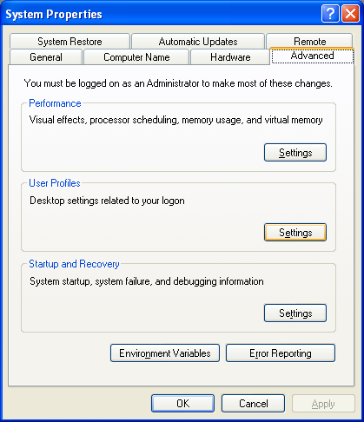
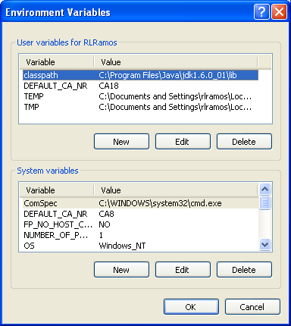
Add the following USER VARIABLES:
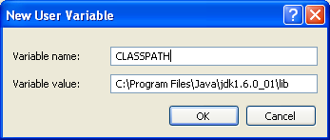
where CLASSPATH is where your JDK’s lib folder is found
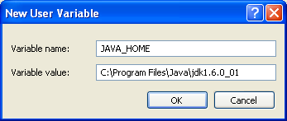
where JAVA_HOME is your JDK install directory
Modify the SYSTEM VARIABLE PATH by adding your JDK install directory’s bin folder
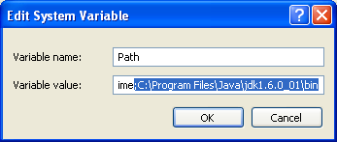
NOTE: Be careful editing this value. You only add it at the end of the whole PATH value.

Step Two – Install Apache Tomcat. Just use the default values.
Step Three – Install Winrar. You will use this to extract Eclipse.
Step Four – Extract Eclipse to a location where you can easily find it.
Step Five – Database Set-up
- Copy the Access Database ADIS.mdb to your computer.
- Go to Control Panel → Administrative Tools → Data Sources (ODBC) → System DSN
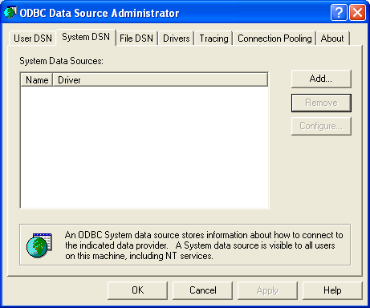
- Click on ADD and select the Microsoft Access Driver. Then click on Finish.
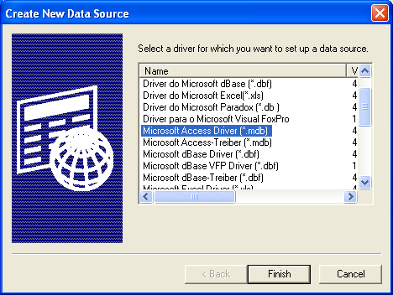
- You will get the ODBC Set-Up window. Name the data source “adis”.
Browse for your adis.mdb file by clicking on “Select”.
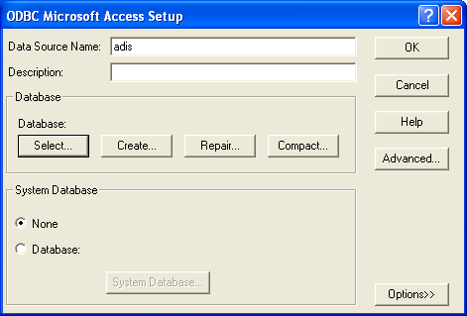
After clicking “Select” look for your MDB file:
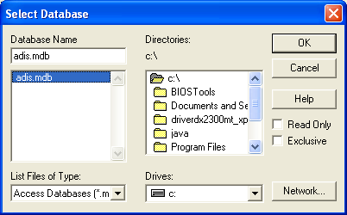
- This is how your screen should look like once you’ve selected your database:
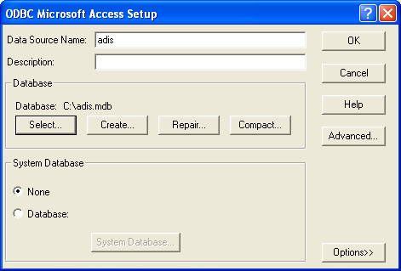
- And this is how the ODBC screen looks like after everything has been done:
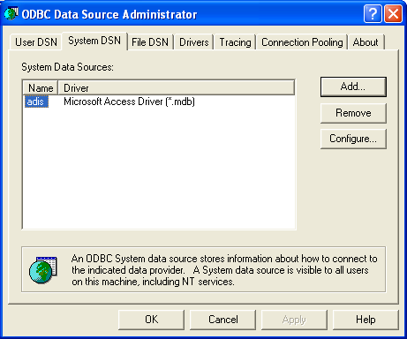

Preparing for Segment 2

- Open Eclipse.
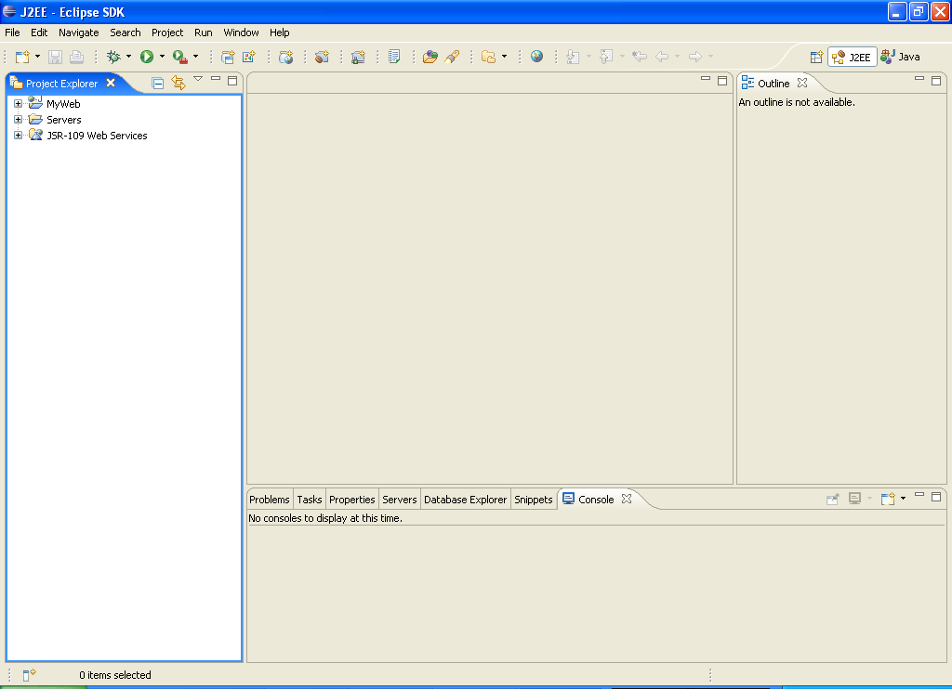
- Create a new Dynamic Web Project
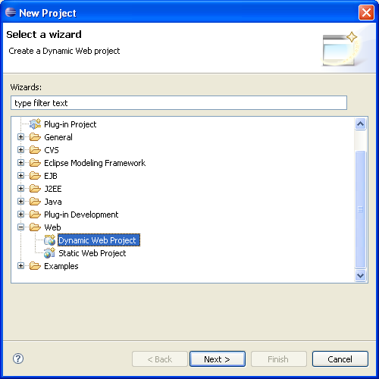
- Fill in the name of the project.
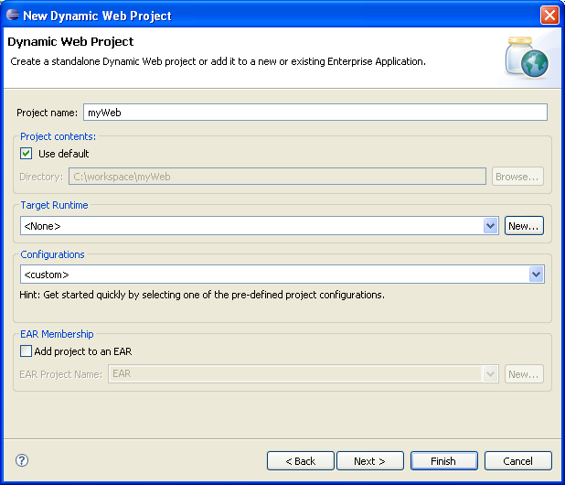
- Set-up the Target Runtime. This will be the webserver your project will use. Click on the “New” button to set this up.
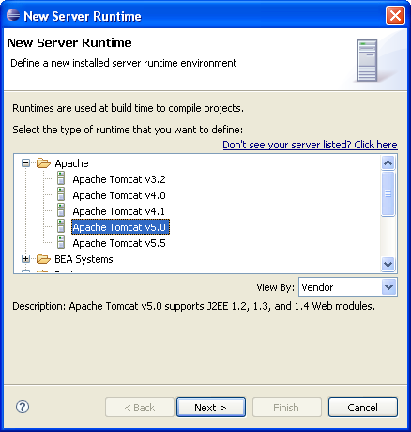
Make sure you select the correct version of Tomcat for this step. Click on “Next”.
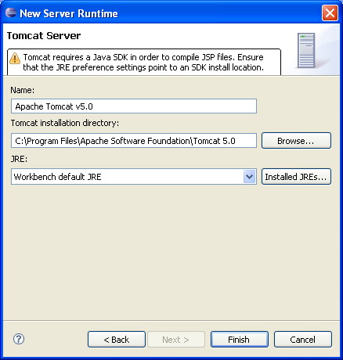
Browse to the main folder of your Tomcat installation and click on “Finish”.
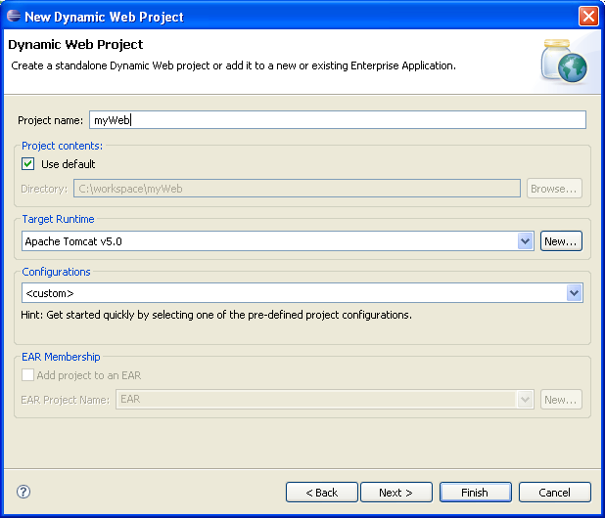
- Click on Finish. You might get the screen below. Click on “Agree”.
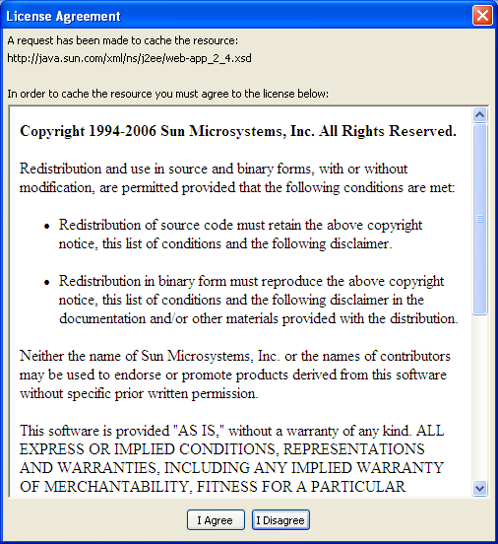
- Eclipse will process your request.
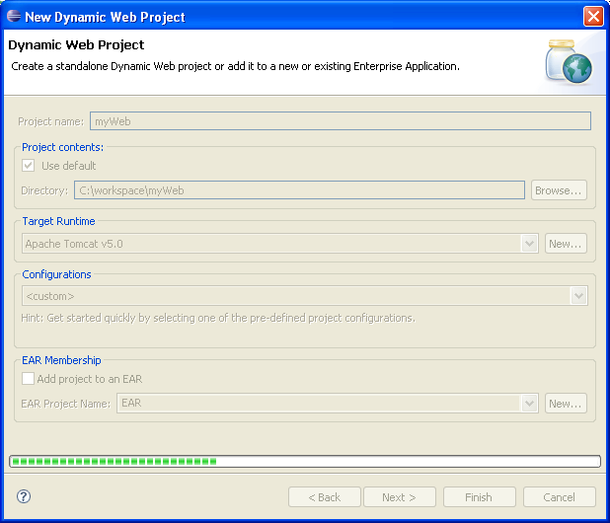
- You will be asked to change to the J2EE perspective. Say “Yes”.
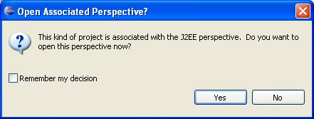
- You are now done with the initial steps.

Importing packages and libraries
- Right click on your project. Select Build Path → Configure Build Path
NOTE: Make sure you right click on the PROJECT itself, not on any other folders.
- Go to the tab for Libraries and remove the “Web App Libraries”
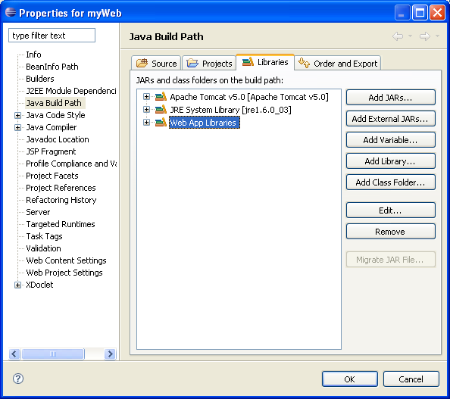
- Add the “External Jar” MyLib.jar which is found in School Files→Access Version→ myLib for Access
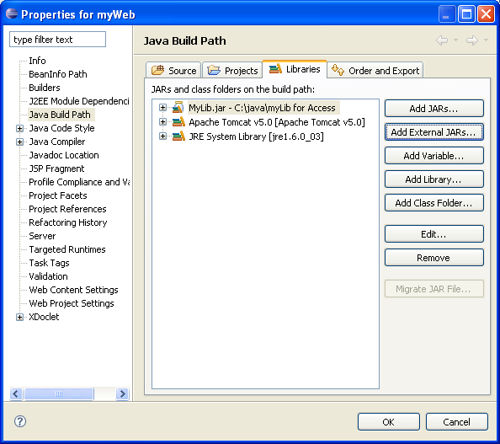Click on OK once MyLib.jar has been added.
- Go to the WEB-INF folder under Webcontent and create a new folder called “CLASSES”
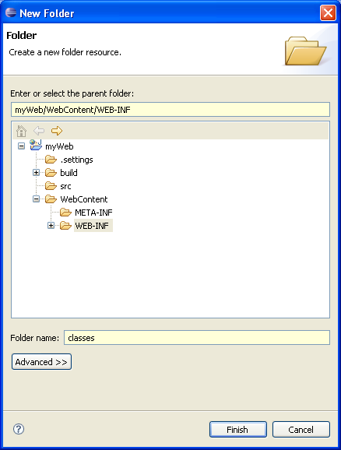
- Right click on the classes folder and select “Import”
Select “General” → “File System”
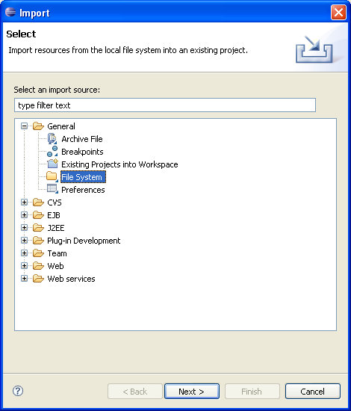
Browse for the class files for Access in “School Files”
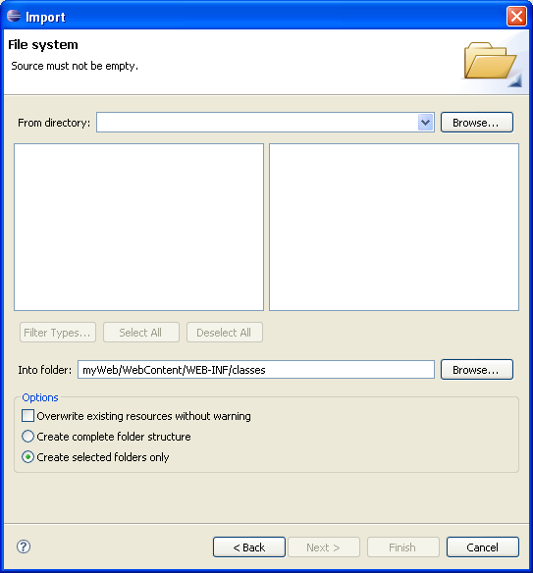
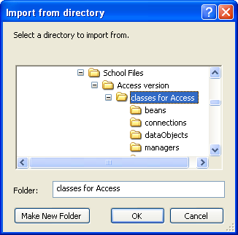
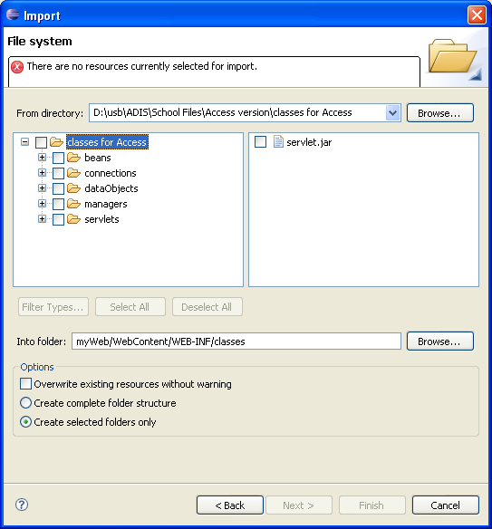
This is the screen that you should see.
- Click on each folder and check files on the right hand box.
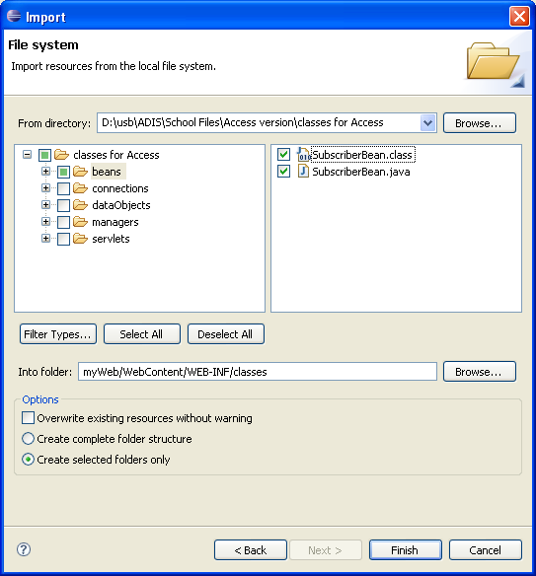
Do this for all the folders listed on the left hand side. Click on “Finish” after.
Your classes folder should look like this after:
- Right click on your project once more and select Build Path → Configure Build Path → Libraries. Select “Add Class Folder”
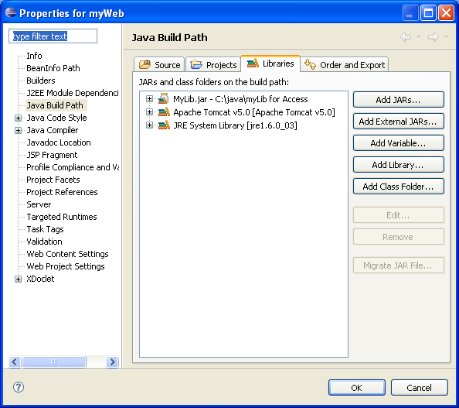
Select the “classes” folder.
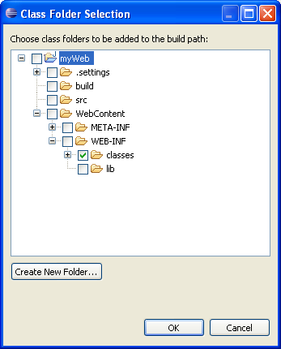
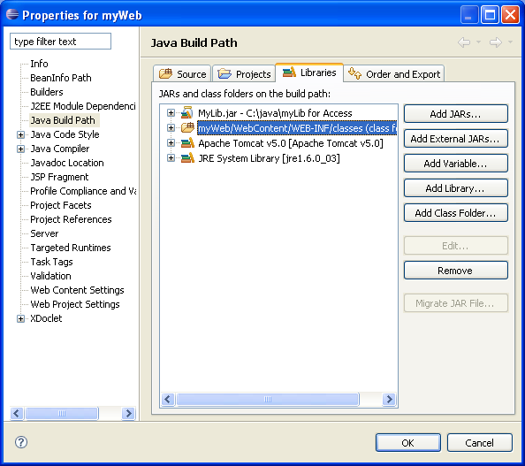
Don’t forget to click “OK” once its added. Your classes folder will disappear from the project explorer. It can now be found in the Java Resource folder as shown below:
- Right click once more on the WEB-INF folder and select import→file system. Browse to School Files and look for the XML folder. Import web.xml.
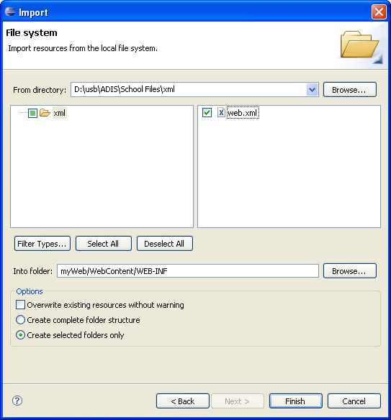
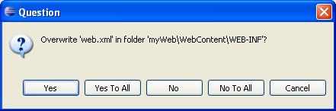
Answer “Yes” to this.
- Your project is now ready for Segment 2.

